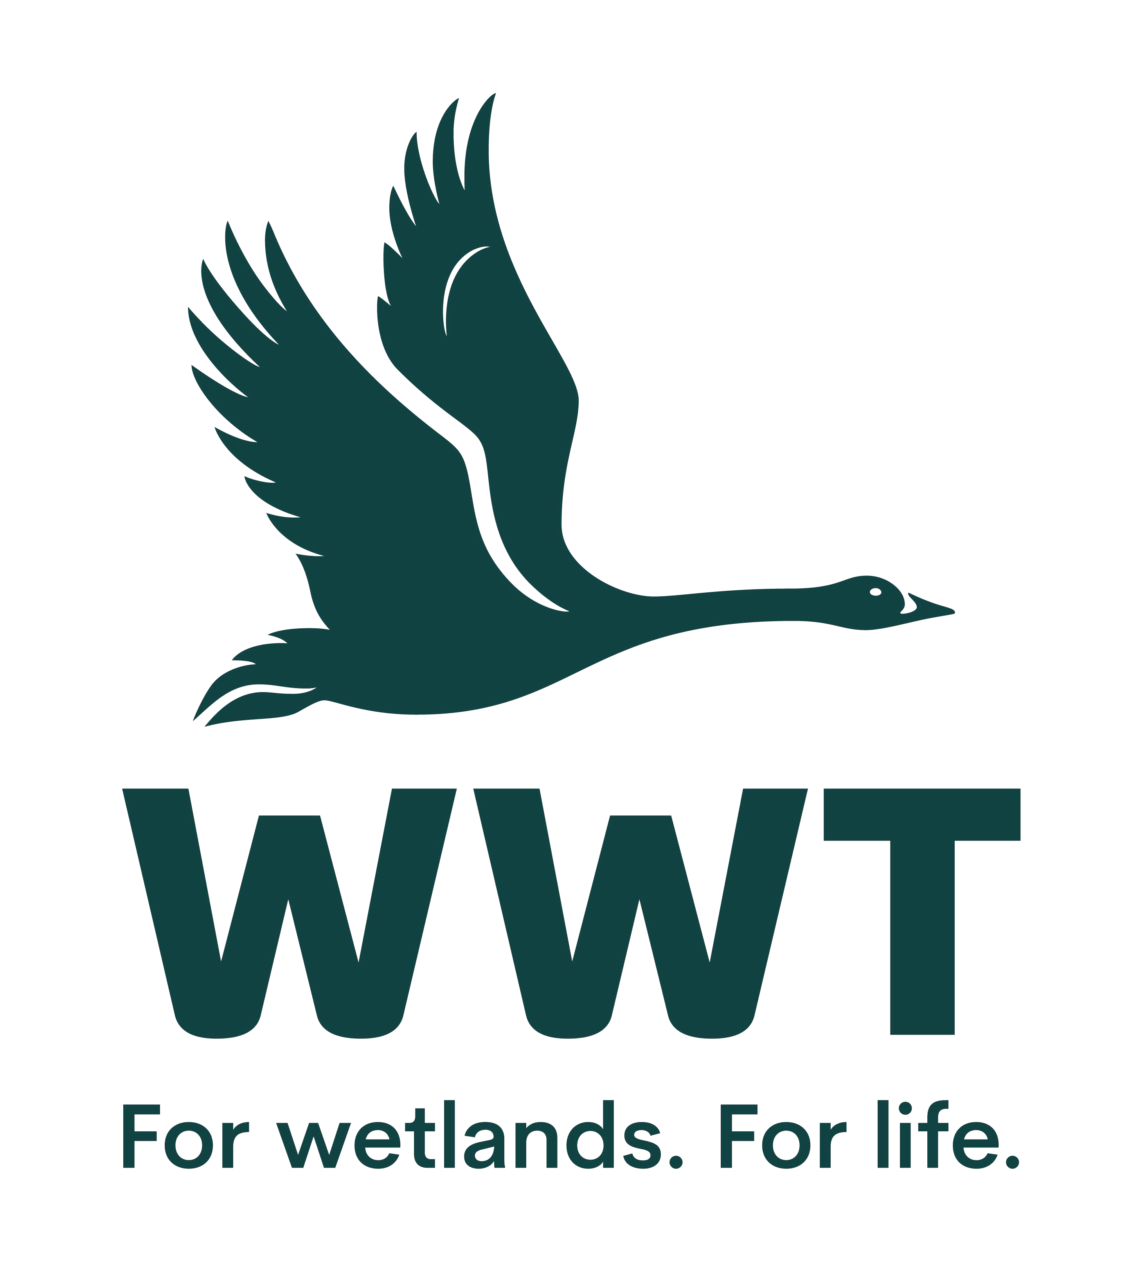

# VOLUNTEER OPPORTUNITY: Safety Management Trainer



**Why do we need you?**

At WWT we shape unforgettable experiences. We are a warm, welcoming and genuine charity that protects and restores Wetlands. In order to do this, we have an amazing team of people dedicated to our mission. To ensure everyone’s safety, and be legally compliant, all of our employees and volunteers have to participate in Health & Safety training.

As a volunteer Safety Management Trainer, you will part of a team contributing to the safety management throughout WWT ensuring that all health and safety requirements are met, keeping us safe and legal.

This role is for somebody who has good communication and people skills and possibly some experience of public speaking but if not, the desire to gain some skills and/or confidence in this area. It would also be helpful if you have some experience or awareness of health and safety. To make our training as accessible as possible, much of our training is delivered online, so it would be beneficial if you are confident in using online meetings.



**Who will be responsible for your role?** Head of Safety Management

**Where will you be based?** You could be home based or at Slimbridge with some travel to sites

**How much time will it take?** We are flexible! You would schedule the training sessions to suit you. So possibly once or twice a month plus some prep time.



# What will you be doing?

* Providing Health & Safety training to staff and volunteers both in person and online via Microsoft Teams video calls.
* Maintaining good relationships with local staff and volunteers.
* Possibly traveling to different WWT sites to deliver the training as and when required.
* Possibly attending Safety Management or Trust training meetings.
* Making a note of any questions and finding out the answers by discussion with Head of Safety Management.

# Who are we looking for?

To carry out this role, you will need:

* A keen passion for and knowledge of safety management.
* Experience of arranging & running workshops or training sessions for groups of people.
* Experience of presenting / engaging with a diverse group of staff and volunteers, both in person and online.
* Good verbal and written communication skills
* IT skills in MS Word, Teams, Powerpoint & Outlook email
* To enjoy working as part of a team
* A commitment to excellent customer service
* The ability to travel to various WWT sites (expenses provided).
* To be reliable and committed to the role and the team
* An interest in and enthusiasm for the work of WWT

# How will you benefit?

* This is an excellent opportunity to work within an internationally important wetland site.
* Join a passionate and inclusive organisation.
* Have fun and meet new people and join an enthusiastic team.
* To feel that you are contributing to the safety of an entire workforce.
* Suitable uniform and a name badge is provided to all regular volunteers
* Discount is available in the café and shop on the days of volunteering
* Free entry to all our sites across the country
* Relevant training opportunities will be provided
* You will be part of a friendly and dedicated team with plenty of opportunities to meet new people



# General notes:

The exact hours you are able to contribute will be discussed prior to placement. We regret we are not in a position to reimburse expenses incurred in travelling to and from the centre nearest to your home, but any pre-agreed expenses incurred in the course of your duties will be reimbursed.

This position is entirely voluntary and is therefore unpaid. Any offer of a volunteer opportunity is not intended to create a legally binding contract between us and any agreement may be cancelled at any time at the discretion of either party. Neither of us intends any employment relationship to be created either now or at any time in the future.



# To Apply: If you are interested in this role, please complete an application form so that we can talk it through further with you.

# If you have any questions, then you can contact Amy / Adele by emailing [volunteering@wwt.org.uk](mailto:volunteering@wwt.org.uk)

**Date raised:** November 2024