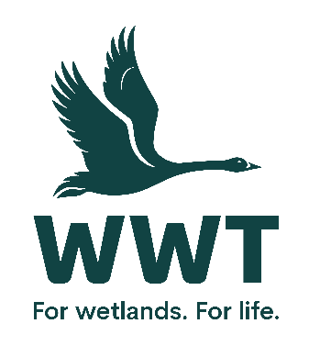

**VOLUNTEER OPPORTUNITY:** Mammal Support Volunteer

**Why do we need you?**

At WWT, we shape unforgettable experiences. We bring awe-inspiring nature up close and let it do the talking. In this role you will help to look after our Asian Small-Clawed Otters and Back from the Brink exhibits (which include Water Voles and Harvest) and engage with the public in understanding more about these species and the conservation threats they face.

**Who will be responsible for your role?** Living Collections Supervisor - Mammals

**Where will you be based?** WWT Slimbridge

**How much time will it take?** 8:00am – 4:30pm, Ideally 1-3 days per week with a 6 month minimum commitment. Details to be agreed.

**What will you be doing?**

Duties may include some or all of the following:

* Helping to prepare the mammal areas for opening at the beginning of each day – checking exhibits, cleaning windows and public area; ensuring all are correct and safe before the visitors arrive.
* Food preparation and feeding of off show and on show species.
* Cleaning and maintaining of all animal areas.
* Interaction with visitors, answering questions and assisting keeper with public presentations.
* Possible assistance in the Ectotherm Section and Living Wetland Theatre.
* Ensure the safety, welfare and enjoyment of the visiting public.

**Who are we looking for?**

No formal qualifications are required. However, this role will suit you if you have formal or informal experience or an understanding of animal husbandry and are:

* Practical and physically able.
* Over the age of 18.
* Able to work in a team of staff and volunteers.
* Experienced in a visitor service environment with a strong commitment to excellent customer service.
* Experienced in mammal husbandry (desirable).
* Proactive and able to work under the direction of the Mammal team as well as lone working.
* Keen to support the work of WWT.
* Sociable and customer-focused.

**How will you benefit?**

* This is an excellent opportunity to volunteer within an internationally important wetland site.
* Suitable uniform is provided to all regular volunteers.
* Discount is available in the cafe and the shop on the days of volunteering.
* Free entry to all WWT wetland centres throughout the UK on presentation of your WWT name badge.
* Appropriate training will be provided.
* A review after the first month to ensure the role is right for you.
* A suitable reference to help you apply for jobs.

**General notes:**

In order for you – and us – to reap the most benefit from this role, we would hope that you could offer a minimum of six months commitment. This position may require work during weekends and public holidays to ensure the objectives of the role are met. Details of the days and hours that you can contribute will be discussed and agreed prior to starting.

Getting to the Centre:   
Road: Slimbridge Wetland Centre is 2 miles off the A38. There is a large car park with ample car parking spaces and there is a bike rack available for staff volunteers.   
Rail: Cam & Dursley rail station is a 3.5 mile cycle or taxi ride away   
Bus: Unfortunately there is no bus service directly to Slimbridge: the nearest services stop is at the A38, 2 miles walk from the Centre. Alternatively there is a bookable shuttle bus called the Robin. More details here: https://www.gloucestershire.gov.uk/transport/the-robin/where-can-i-travel/berkeley-vale/

This position is entirely voluntary and is therefore unpaid. Any offer of a volunteer placement is not intended to create a legally binding contract between us and any agreement may be cancelled at any time at the discretion of either party. Neither of us intends any employment relationship to be created either now or at any time in the future.

**How to Apply:**

Please apply online via our website at: <https://www.wwt.org.uk/vacancies>. ​If you are interested in volunteering for WWT but don't wish to apply online, please email [volunteering@wwt.org.uk](NULL) or leave a message at 01453 891 231 with your name and number.

**Date raised:**  August 2025