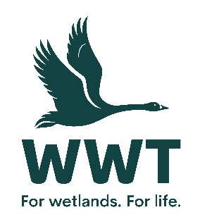

**VOLUNTEER OPPORTUNITY:** Ectotherm (Toad Hall) Volunteer

**Why do we need you?**

At WWT, we create and conserve wetlands and save species. We bring awe-inspiring nature up close and let it do the talking. In this role you will primarily help to look after the animals in our ‘Toad Hall’ exhibit, and engage the public in understanding more about these creatures and the conservation threats they face. As part of your role you will assist with daily animal husbandry duties and assist in observational behaviour recording. From time to time you will also provide support into other areas of the ‘Living Collections’ department, volunteering with mammals and in aviculture.

**Who will be responsible for your role?** Livings Collection Supervisor Ectotherms

**Where will you be based?** WWT Slimbridge Centre

**How much time will it take?** Ideally we are looking for a commitment of at least one day a week for a minimum of 3 months but can be flexible dependent on the volunteer’s needs.

**What will you be doing**

* Data recording for life support systems.
* General maintenance of public and back of house areas
* Water changing and exhibit maintenance.
* Helping with feeding, new projects and stock management.
* Conducting interactive presentations to engage the general public in the work of WWT, the amphibians in the Toad Hall exhibit, and wider conservation messages (training provided)
* Research and observations recording
* Adhering to all bio-security and hygiene protocols across the Living Collections

**Who are we looking for?**

There are two parts to this role: assisting with daily animal management duties in the Living Collections department and engaging our visitors on the amphibians and the work of Living Collection. Both aspects are equally important, and so we are looking for volunteers with the following:

* Basic animal husbandry knowledge, with a particular interest in amphibians would be advantageous
* Excellent customer service skills; confidence and enthusiasm when engaging the public
* Good physical health – this role will involve some manual handling
* Good attention to detail and able to follow instructions
* The ability to work on your own initiative under the direction of the Ectotherm team

**How will you benefit?**

* This is an excellent opportunity to volunteer within an internationally important wetland site.
* Suitable uniform is provided to all regular volunteers.
* Discount is available in the cafe and shop on the days of volunteering.
* Free entry to all WWT wetland centres throughout the UK on presentation of your WWT name badge.
* Appropriate training will be provided.

This position may require volunteering during evenings, weekends and public holidays to ensure objectives are met. The exact hours you are able to contribute will be discussed prior to placement, but this could be any day of the week.

There are limited public transport routes to Slimbridge Wetland Centre, please see our website for travel details. We regret that we are not in a position to reimburse expenses incurred for travel to the site.

Any pre-agreed out-of-pocket expenses incurred in the course of the role will be reimbursed.

This position is entirely voluntary and is therefore unpaid. Any offer of a volunteer role is not intended to create a legally binding contract between us and any agreement may be cancelled at any time at the discretion of either party. Neither of us intends any employment relationship to be created either now or at any time in the future.

**Date raised:**  January 2018 **Date Reviewed**: August 2025 SG