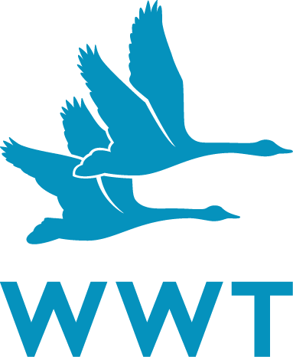 Wetlands are amazing

London Wetland Centre is looking for friendly and enthusiastic individuals to join our trading team.

**Casual Trading Assistant**

**London Wetland Centre**

**Various hours to be worked on an ad-hoc basis**

**£13.15 per hour**

We have a perfect opportunity for a Trading Assistant to help our Retail team at WWT London Wetland Centre. Our friendly team are ready to welcome you to the pond.

​

Working at London you can actually make a difference to conserving out planet. Reducing the world’s impact on climate change, whilst inspiring visitors and encouraging them to get closer to nature by providing outstanding service is our number one priority.

We are seeking enthusiastic and customer-focused individual to join our team as a Casual Trading Assistant. In this role you will support the day-to-day operations of our Retail and Membership Services.

​

You will need to be happy greeting customers, maintaining stock levels in the shop and assisting with signing new members up.

​

Key Responsibilities:

* Provide excellent customer service.
* Assist in the daily operations of the shop.
* Support membership related activities such as sign ups, renewals and resolving membership enquiries.
* Create an overall welcome experience that reflects the values of WWT.

Preferable Qualities:

* Previous retail or customer service experience is preferred but not essential.
* Strong communication and interpersonal skills, with the ability to built rapport with customers.
* Flexibility to work varying shifts, including weekends and public holidays.
* Passion for wildlife is preferred.
* A positive attitude and willingness to learn new skills.

Postal address: WWT London Wetland Centre, Queens Elizabeth Walk, Barnes, SW13 9WT

The Wildfowl & Wetlands Trust (WWT) is a conservation charity that protects wetlands for wildlife and people. We conserve, restore and create wetlands. We are pioneers in saving wetland wildlife, both in the UK and around the world. At our 10 UK sites around a million visitors a year engage with wetland nature. We work internationally in key global wetland areas, balancing conservation with sustainable livelihoods and influencing national and international conservation policies.

Please note that if you are applying for the above position you must be legally eligible to work in the UK and be able to provide documents at interview stage to confirm this.

WWT is an equal opportunities employer and all applications will be considered solely on merit.

Registered Charity Number England & Wales, no 1030884 and Scotland, no SC039410