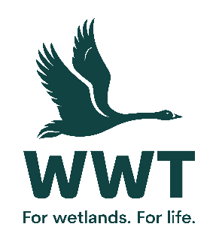
VOLUNTEER OPPORTUNITY: Welcome and Information Team Assistant
At WWT we believe the best way for people to understand and connect to wetlands is to experience them, so we bring awe-inspiring nature up close and let it do the talking. People feel part of something amazing and are motivated to make a difference.
By providing an excellent visitor experience as a member of the Welcome and Information Team, you will be encouraging our visitors to make the most of their visit to Martin Mere centre, and to understand and support our work to save wetlands for wildlife and people.

Volunteers play a crucial role in saving wetlands for wildlife and people.
This role involves:
- Acting as the first point of contact for all visitors to Martin Mere, providing them with a warm welcome along with appropriate information to aid their visit.
- Conducting specific talks to the public – scripts and training are provided.
- Conducting activities such as opening the moth traps and using props to actively engage with visitors
- Conducting guided walks of the grounds and the reserve when required – training is provided.
This role will suit you if:
No previous experience is required as training will be provided. However this role will suit you if you have a love of wildlife and the outdoors and are:
- Confident or experienced in delivering talks
- Able to work in a team of staff and volunteers
- Experience in a customer related role would be advantageous
- Able to communicate well to a diverse range of audiences
- Familiar with Martin Mere centre
Practicalities
Where will you be based? Martin Mere Wetland Centre
Who will you volunteer with? A team of volunteers
Time commitment? The desk is open from 9.30am until 3.30pm. Morning or afternoon options are available. We are currently looking to recruit for a Sunday.
We want your volunteering to be a positive and fun experience. You’ll get a warm welcome, including information on training, equipment and other information you need. This will include risk assessments based on your role and any particular support you need.
Volunteers receive access to our sites, and discounts in our shops and cafes. Some roles include a uniform or require the use of equipment or protective clothing.
If you are based at a particular site or office location, you’ll need to be able to get yourself there and back. Information on locations can be found on our website.
If you are interested in volunteering for WWT but don't wish to apply online, please email volunteering@wwt.org.uk or leave a message at 01453 891 231 with your name and number.
We will keep you up to date with what’s happening across WWT and the difference you will be helping to make happen.
Interested?
If you are interested in this role, please complete an application form so that we can talk it through further with you.

