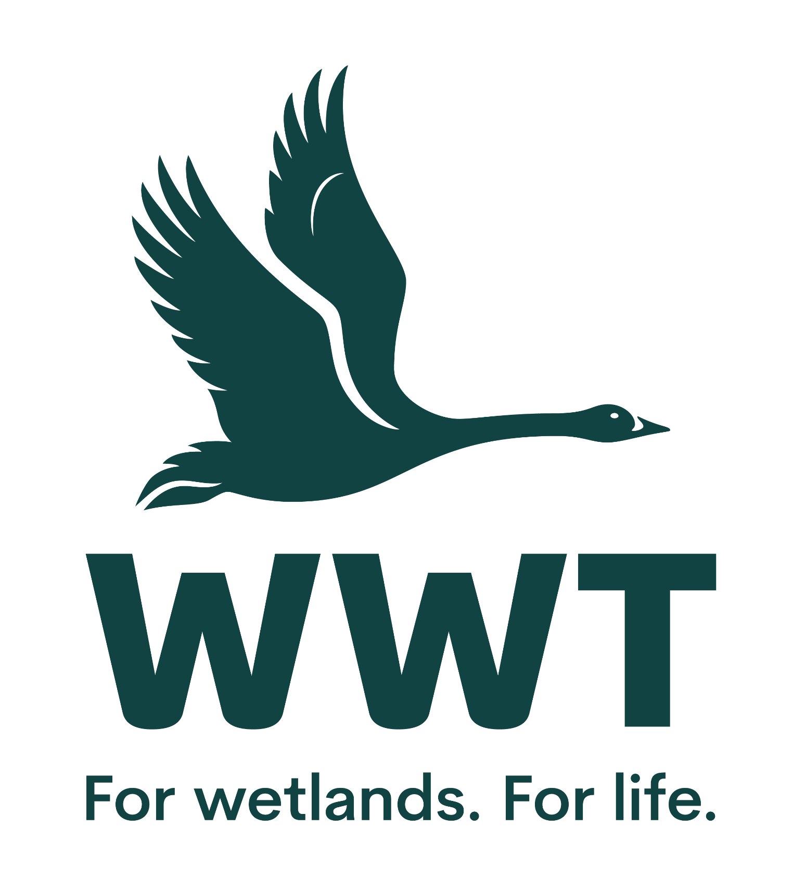
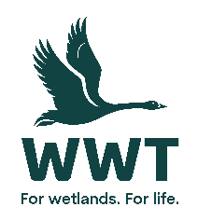 Job Description
Senior Project Manager (Major Projects Saltmarsh)

Grade:10

Directorate: Major Projects
Location: WWT Slimbridge with regular travel to Awre, Forest of Dean and other locations in the Severn Estuary.

Reporting to: Head of Major Projects (Saltmarsh)

Main function of post:
To project manage delivery of a major saltmarsh restoration projects in the Major Projects (Saltmarsh) portfolio, all with multiple benefits. The efficient management and co-ordination of all aspects of the project involving multiple internal and external teams and contributors.

Supervisory responsibilities:
Stakeholder Management Officer, multiple consultants and contractors and indirect matrix management of wider WWT project teams

Responsibilities of the post
- To be responsible for the delivery of a major saltmarsh restoration project in Awre, Forest of Dean delivering multiple benefits for wildlife and people, and including mitigation for the impacts of climate change and flooding.

- To provide direction, co-ordination and leadership to project staff and volunteers and matrix management of multiple contributing staff and teams across multiple WWT Directorates, enabling every team members contribution to be maximized by ensuring the appropriate level of direction and support are provided
.
- Manage all aspects of project delivery including engagement of multiple external and WWT stakeholders, consultants and contractors across development and construction stages, delivery to budget and programme, and risk management and transition on completion to WWT operations teams

- To include co-ordination of multiple contributing objectives in such areas as research, monitoring, partner relationships and engagement, communications, and community liaison, working closely at all times with other WWT teams and specialist leads.

- To take responsibility for budgeting and managing project resources, including signing off on project expenditure within approved limits (and escalating where necessary)
- To support exchange of experience and ongoing professional development, and to provide support and advice to other projects and teams whenever possible.

- To develop and execute with relevant support an efficient internal project communication strategy
- To ensure that health, safety and wellbeing of everyone in your teams is an integral part of how they work, creating a safe environment for staff, volunteers and visitors by implementing WWT’s health and safety policies and guidelines.
- To be responsible for ensuring that the project teams engage with the WWT Sustainability Statement being aware of negative environmental impacts and incorporating sustainable ways of working.
- To ensure that your teams engage and interact with our visitors and supporters in a positive way, shaping unforgettable experiences and helping them understand and connect to wetlands.

- To ensure that everyone in your teams adheres to WWT’s Data Protection policy and GDPR standards as an integral part of how they work.
In addition to the duties and responsibilities listed, the post holder is required to perform any other reasonable duties that may be assigned by the supervisor shown above, from time to time.
Date raised: Jan 2025 Amended:

Person Specification

1. Qualifications

Essential:
- Degree level qualification in a relevant discipline or other professional qualification or significant relevant experience in a similar role
- Current driving licence as the ability to travel to other locations is essential

Desirable:
- A recognised qualification or accreditation in project management (e.g. PRINCE2, APM accreditation)

2. Experience

Essential:

- Experience of managing large-scale, multi-stakeholder projects
- Experience of wetland habitat restoration and creation design and practice preferably in a coastal environment
- Experience of project design, planning and evaluation
- Proven experience in networking, partnership building and relationship management
- Demonstrable experience of implementing effective governance arrangements to ensure timely decision making, effective risk management, and compliance with organisational policies
- An excellent track record of building and managing a team
- Excellent IT skills including use of Microsoft Office Outlook, Word, Excel and PowerPoint

Desirable:

- Experience in managing / understanding statutory grants
- Knowledge of the UK planning system and environmental regulation
- Experience of working with volunteers and communities

Managerial & Supervisory

Essential:
- Ability to work effectively with others, engaging multi-functional and cross-directorate teams in project delivery
- Ability to lead, manage and motivate a team

Type of team member | Number managed  (No. of direct reports) | Number supervised
Employed staff | 1 | 10+
Volunteers | 2 | 10+
Casual Workers | 0 | 0

Includes multiple matrix managed staff managed/supervised across multiple Directorates potentially in excess of 10

4. Responsibility

Essential:
- Ability to take responsibility for large, diverse projects and prioritise resources accordingly
- Ability to assess both physical and reputational risks of a project and make informed decisions
- Outstanding self-management skills to work independently, autonomously and as part of a team, using own initiative and being flexible and adaptable.
- Ability to manage project related budgets of at least £1 million
- Excellent planning and organisation skills to deliver work to agreed timescales and standards

Levels of Responsibility:
Type of Responsibility | Level (£’s)
Budget Responsibility | Up to £10K
Income | N/A
Project Size (normally managed) | Major
Assets (required for job, exc. buildings) | Up to £10K
Visitors (number per annum) | N/A

5. Creative Ability

Essential:
- Excellent problem-solving skills and an eye for detail
- A high level of original thought and creative approach
- Able to be resilient in overcoming barriers, recovering from setbacks and identifying lessons learnt
- Excellent planning and organization skills to deliver work to agreed timescales and standards

Desirable:
- Experience of production of creative communication and engagement assets

6. Contact

Essential:
- Excellent written and oral communication skills to write reports and deliver presentations
- Ability to represent an organisation effectively to partners/stakeholders and at external events
- Effective team-working and collaboration skills
- Outstanding interpersonal skills including being able to negotiate, give feedback, persuade, influence, deal with conflict, influence, and work effectively with groups and individuals including those with differing perspectives and in complex and challenging circumstances
- Ability to collaborate with and influence personnel from external stakeholders, demonstrating advocacy and communication skills.
- Ability to maintain a network of external contacts, statutory agencies, academia and/or NGO’s relevant to the project.

Desirable:

General Notes
This position will from time to time require work during some evenings, weekends and public holidays to meet the needs of the post

