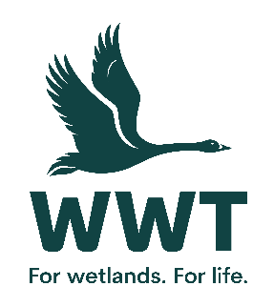
VOLUNTEER OPPORTUNITY: Living History Assistant
At WWT we believe the best way for people to understand and connect to wetlands is to experience them, so we bring awe-inspiring nature up close and let it do the talking. People feel part of something amazing and are motivated to make a difference.
By providing an excellent visitor experience as a member of the Living History team, you will be bringing wetlands throughout history, and the history of the mere to life by delivering key messages about how important wetlands are for food, materials, medicine and livelihoods. This encourages our visitors to make the most of their visit to Martin Mere, and to understand and support our work to save wetlands for wildlife and people.

Volunteers play a crucial role in saving wetlands for wildlife and people.
This role involves:
- Undertaking talks and hands-on activities in our Mere Tun Village about how useful wetlands are. Specifically about villagers settling next to wetlands 1000 years ago to provide them with food, materials for shelter, medicine and items to trade.
- Undertaking talks in our Mere Tun Village about the history of the mere and development of Martin Mere
- Assisting with activities when Mere Tun Village is open as a working village to our visitors in school holidays and weekends.
- Communicating WWT conservation messages and membership during talks about how people in places such as Madagascar still make settlements next to wetlands for their livelihoods.
This role will suit you if:
No previous experience is required as training will be provided. However this role will suit you if you have a love of wildlife and the outdoors and are:
- A good knowledge of local history
- Confident or experienced in delivering talks
- Able to work in a team of staff and volunteers
- Experience in a customer related role would be advantageous
- Able to communicate well to a diverse range of audiences
- Familiar with Martin Mere centre
Practicalities
Where will you be based? Martin Mere Wetland Centre
Who will you volunteer with? A team of volunteers
Time commitment? Negotiable
We want your volunteering to be a positive and fun experience. You’ll get a warm welcome, including information on training, equipment and other information you need. This will include risk assessments based on your role and any particular support you need.
Volunteers receive access to our sites, and discounts in our shops and cafes. Some roles include a uniform or require the use of equipment or protective clothing.
If you are based at a particular site or office location, you’ll need to be able to get yourself there and back. Information on locations can be found on our website.
If you are interested in volunteering for WWT but don't wish to apply online, please email volunteering@wwt.org.uk or leave a message at 01453 891 231 with your name and number.
We will keep you up to date with what’s happening across WWT and the difference you will be helping to make happen.
Interested?
If you are interested in this role, please complete an application form so that we can talk it through further with you.

