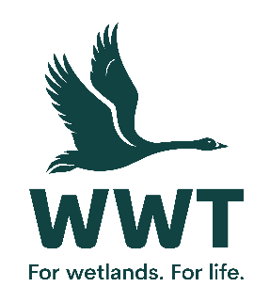
VOLUNTEER OPPORTUNITY: Health & Safety Administration Volunteer
Do you have experience working in a proactive health and safety environment and have a great attention to detail? We’re looking for someone that can help our small and busy team with keeping our wonderful site at Welney a safe place to be for all of our visitors, and our staff and volunteers.
By working as part of the Health and Safety Team at Welney, you will be providing support to our staff and assisting with information for our reports.
All our volunteers play a crucial role in saving wetlands for wildlife and people, and through this role, you will help ensure that our site can remain a safe and welcoming one.

This role involves:
- To help with keeping our Health and Safety records up to date, with regular input of information into spreadsheets and databases.
- Receiving information from colleagues at WWT, and inputting these into our Health & Safety monitoring systems
- To help promote a positive health and safety culture throughout the Welney Wetland Centre and where needed, represent aspects of this at team meetings.
- Promote and monitor the teams basic Health & Safety training (delivering WWT training may also be an option, as agreed)
- To help with keeping our Health and Safety records up to date.
This role will suit you if:
You are keen to support the work of WWT and have formal or informal experience or understanding of health and safety. This role is administrative and office based, so being confident using Microsoft Office, spreadsheets and/or databases would be important.

You will need to be proactive and comfortable working on your own initiative and independently, with some supervision, also comfortable communicating with people at other levels of WWT.

It’s a friendly working environment at Welney – having good interpersonal skills and being happy to work as part of a well-blended staff and volunteer team will bring you into the fold.
This role is only suitable for people over 18 years of age.
Practicalities
Where will you be based? Welney Wetland Centre
Who will you volunteer with? Welney’s Safety, Health & Environment Team, led by David Tough, Grazing Officer
Time commitment? Ideally half to one day per week, timings to be agreed
We want your volunteering to be a positive and fun experience. You’ll get a warm welcome, including information on training, equipment and other information you need. This will include risk assessments based on your role and any particular support you need.
Volunteers receive access to our sites, and discounts in our shops and cafes. Some roles include a uniform or require the use of equipment or protective clothing.
If you are based at a particular site or office location, you’ll need to be able to get yourself there and back. Information on locations can be found on our website.
If you are interested in volunteering for WWT but don't wish to apply online, please email volunteering@wwt.org.uk or leave a message at 01453 891 231 with your name and number.
We will keep you up to date with what’s happening across WWT and the difference you will be helping to make happen.
Interested?
If you are interested in this role, please complete an application form so that we can talk it through further with you.

