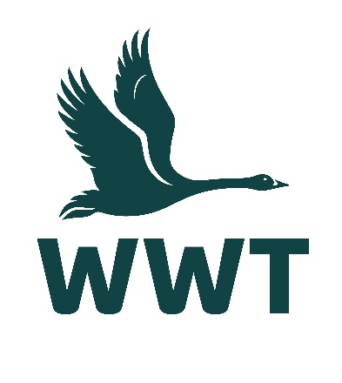
______________________________________________________________

VOLUNTEER OPPORTUNITY: Mammal Support Volunteer
(Living Collections)
______________________________________________________________

About the role
At WWT, we believe that the best way for people to understand and connect to wetlands is to experience them, so we bring awe-inspiring nature up close. In this role, you will be helping to look after our Asian small-clawed otters and “Back from the Brink” exhibit species, including water voles and harvest mice.
You will be engaging with the public to help them understand more about these species and the conservation threats facing them. This is an excellent opportunity to gain practical experience of animal husbandry and uphold outstanding standards of care for our mammal collection species.
Volunteers are an essential part of the WWT team, and we wouldn’t be able to maintain our internationally important wetland sites without their help. You will receive a very warm welcome, full induction & training, and be provided with any necessary equipment, uniforms, and anything else needed to thrive in your role.

Main tasks
- Cleaning & maintenance of facilities and mammal exhibits to maintain high standards of animal welfare and prepare for daily opening to visitors
- Contributing to daily food preparation and assisting with feeding routines of on and off-show species
- Assisting keepers with public presentations, visitor engagement and interaction, and answering queries from members of the public
- Following health & safety guidelines and ensuring the safety and welfare of our animals and the visiting public
- Potential scope for assisting the “Living Wetland Theatre” and “Ectotherm Section” departments
Role practicalities
Location: | WWT Slimbridge
Manager: | Living Collections Supervisor (Mammals)
Days: | We are looking for volunteers who are available to help out 1-2 days per week from 08:00 – 16:30.
Time commitment: | To ensure a positive volunteering experience for you and to provide a helpful contribution to the organisation, we hope you will be able to volunteer with for us for at least six months.
Age restrictions: | This role is not suitable for people under 18 years.
Additional notes: | This is an unpaid voluntary position. Unfortunately, WWT are not currently able to reimburse travel expenses for volunteers.

About you
No previous experience is required for this role as full training will be provided, and a willingness to learn new skills is more important.
This role would suit you if:
- You have (or would like to gain) experience in animal husbandry
- You feel confident in talking to and engaging with members of the public
- You are physically fit and practically minded
- You have an interest in and enthusiasm for the work of WWT
- You enjoy working as part of a team of staff and volunteers
- You have a strong commitment to excellent customer service
- You are reliable and committed
- You are willing to get stuck into working outdoors and in all weathers

About us
We are WWT, and we’re on a mission to restore the super-powered ecosystems we call wetlands. There’s never been a more important moment for our work, and we’ve got some phenomenal people on the case.
Whether you’re looking to meet new people, learn new skills or spend time in our wildlife-rich wetlands, there’s a volunteer role for you. Just a few hours spent volunteering can really make a world of difference to our wildlife, and to you.
So, come surround yourself with the wonder of wetlands, and the people who inject their energy and passion into them. Whatever you do here, you’ll be helping to restore wetlands and unlock their power. The only question left is, what role will you play?

Why you’ll love volunteering at WWT
- Make a real contribution to the conservation and engagement work of WWT
- Work at one of our beautiful and internationally important wetland sites
- Be surrounded and inspired by like-minded nature lovers who bring energy, passion, and expertise to their role
- Make new friends and become part of a friendly and inclusive community
- Gain volunteering experience and learn & develop new skills
- Get volunteer discounts for WWT shops, café, and membership
- Get free entry to all our UK wetland centres, including for your family
- Receive access to wildlife talks, webinars, and practical information to help you manage your volunteer role & daily life
- Be kept informed about what’s happening in our organisation and the positive change you are helping to make happen

Interested in applying?
Please apply for this volunteer role via our website - we look forward to receiving your application!
We celebrate inclusivity and diversity amongst our volunteering community and actively welcome applications from individuals of all backgrounds. If you have a disability or think you may need additional support to carry out a volunteering role, please state the relevant details on your application form so that we can support you with your volunteering experience.
If you are unable to apply online via our website, please email volunteering@wwt.org.uk for further assistance.

