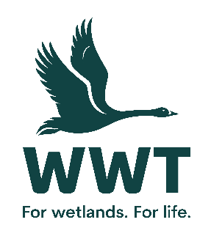
VOLUNTEER OPPORTUNITY: Weekend Family Activities Assistant
At WWT we believe that the best way for people to understand and connect to wetlands is to experience them so we bring awe-inspiring nature up close. You will be directly involved in shaping our visitors’ unforgettable experiences through your warm welcome, your interaction with them and the information that you provide. Activities include pond dipping, bug hunts, animal health checks, living history experiences and egg to duckling activities.
Volunteers play a crucial role in saving wetlands for wildlife and people.
This role involves:
- Delivering wildlife activity sessions to families e.g. pond dipping, bug hunts at the weekend
- Helping with seasonal children’s activities such as Pumpkin carving, Christmas crafts or even being an elf!
Full training will be provided.
This role will suit you if:
No previous experience is required as training will be provided. However this role will suit you if you have a love of wildlife and the outdoors:
- Experience either in an educational setting or in an environment involving children would be an advantage
- Reliability and people who are prepared to make a commitment to volunteering
- Confident in talking to the public
- Able to work in a team of staff and volunteers
- Keen to give our visitors a first class experience
- Able to communicate well to a diverse range of people, young and old
Practicalities
Where will you be based? Martin Mere Wetland Centre
Who will you volunteer with? A team of volunteers
Time commitment? Activities tend to be either a morning or afternoon at the weekend
We want your volunteering to be a positive and fun experience. You’ll get a warm welcome, including information on training, equipment and other information you need. This will include risk assessments based on your role and any particular support you need.
Volunteers receive access to our sites, and discounts in our shops and cafes. Some roles include a uniform or require the use of equipment or protective clothing.
If you are based at a particular site or office location, you’ll need to be able to get yourself there and back. Information on locations can be found on our website.
If you are interested in volunteering for WWT but don't wish to apply online, please email volunteering@wwt.org.uk or leave a message at 01453 891 231 with your name and number.
We will keep you up to date with what’s happening across WWT and the difference you will be helping to make happen.
Interested?
If you are interested in this role, please complete an application form so that we can talk it through further with you.

